Unisys Portal Instructions

You will use this site to find your PARTS ETA, parts TRACKING NUMBERS and ADDRESS of where your parts are shipping to. You will also be able to see if an Appointment Booking has been scheduled.

Go to this site:

https://portal.unisys.com/portal/page/portal/ESERVICE_PGR/global/SERVICE_CONSOLE_LOGIN

Log in using:

smartech@smartech-csi.com

Use password:

smartech1

**This is everyone’s log-in to do not alter.

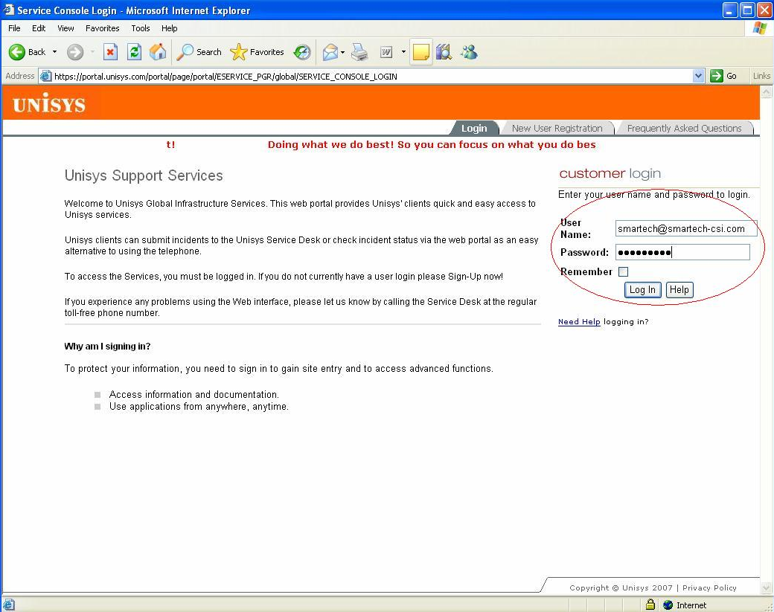

click on the tab that says “Main”

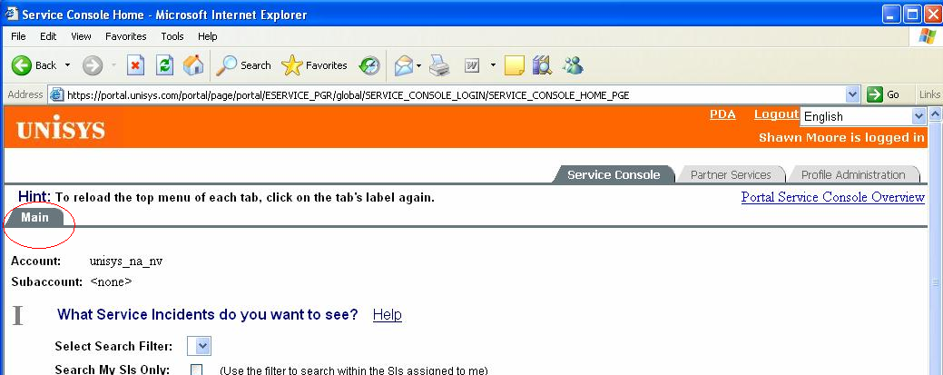

Next to Roman numeral 1

Select Search Filter: should default to “Closed less than 7 days” or it may be blank,
next to “Specific Incidents” type in your call# (example 57981390)

Next to Roman numeral 2

Output should be “table”
Summary View should default to “Address”
Max lines per page should be “500”
Detail view should be “short” and “Show Ok’ed Notes” should be checked

Hit “View Service Incidents”

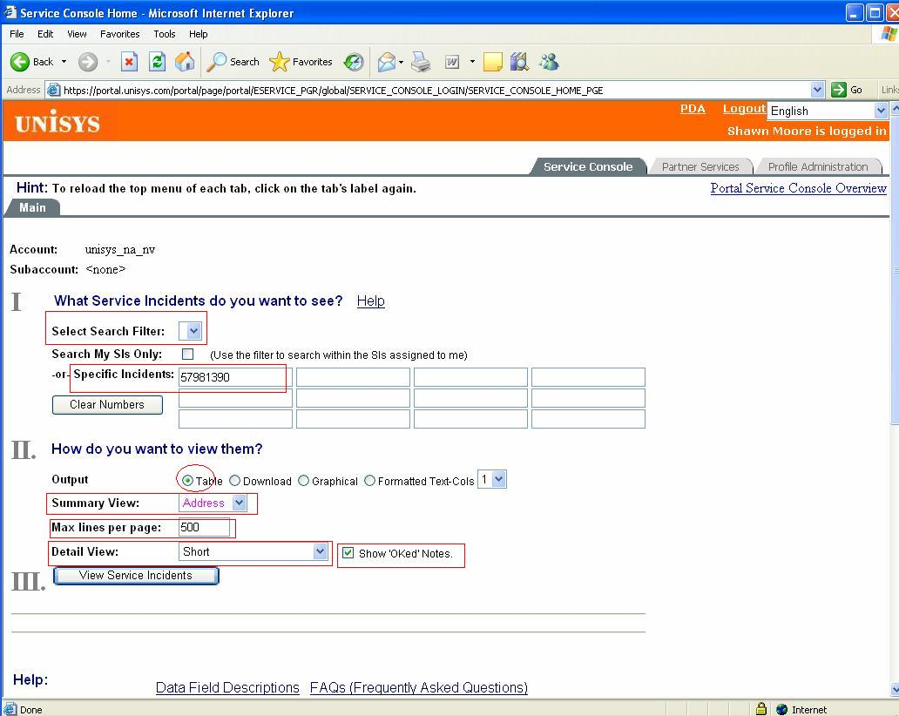

On the next screen next to “Select sections to display:” place a check mark in front of the boxes that says: Parts, Notes, Related, Resolution

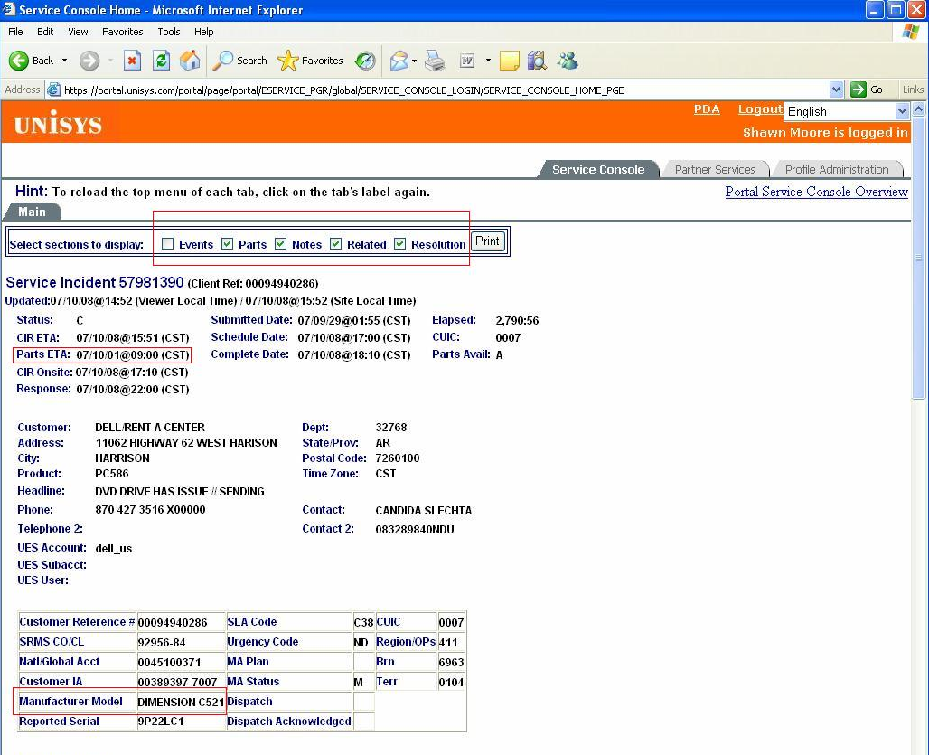

You want to look for PARTS ETA for the date and time when parts should be arriving. Next you want to scroll down and look for Manufacturer Model to know what type of computer you will be working on. Just below that you will see Category Notes with Sequence #’s. You are looking for any comments that describe problems the end user is having with the computer and for any alternate contact names and phone numbers. You will also be looking for Appt Bookings (ex. 930am-530pm). This means that Dell has already scheduled with the end user to have a technician at their location anytime between these hours.

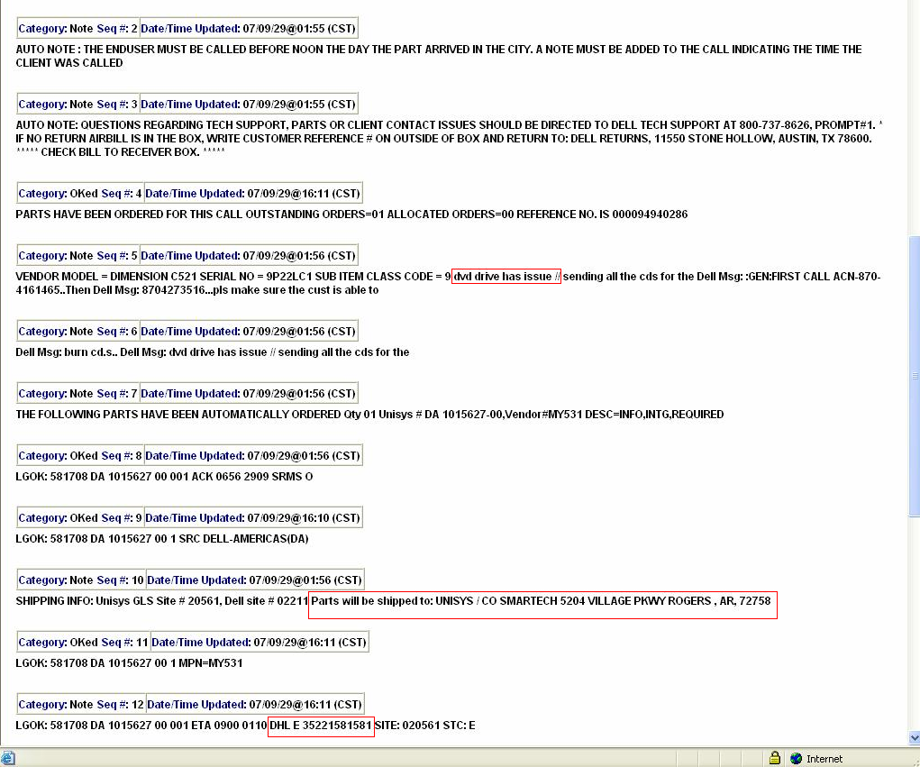

You scroll down a bit more and are looking for Shipping Info that has the address of where parts are shipping to. Below that you are looking for a DHL, Fedex or UPS tracking number so that you can take that tracking number to the DHL, Fedex or UPS website and track your parts. THE WAYBILL # OR AIRBILL # IS ALWAYS LOCATED AFTER THE WORD “PRIOR” IN THIS SYSTEM.

You should then be able to know what parts are shipping and what are not so that you can call your customers and schedule your calls.

